YOUTH TRAINING ACADEMY 2019
12-17th November
Algeria, Tlemcen
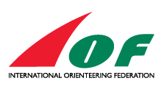 |  |  |  | 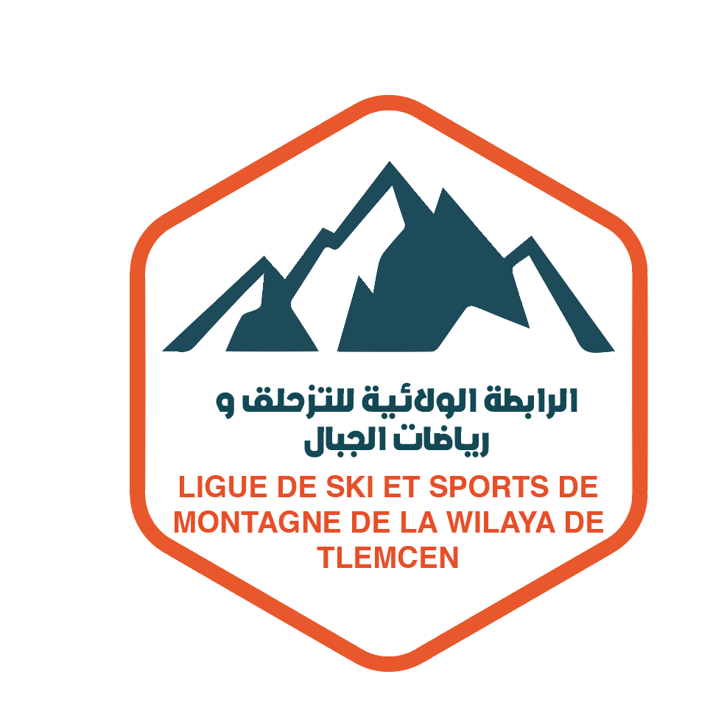
partners in project


PRELIMINARY (QUANTITATIVE) ENTRY FORM
To be sent latest until 31st August 2019. to the e mail: comof.secretary@gmail.com
Country
Name of responsible person
E mail, mobile phone

Entry for the training camp
W18 | W20 | M18 | M20 | Coaches
write number of persons in each class
Booking for the accommodation
Accommodation type | Number of persons MEN | Number of persons WOMEN
A- Youth Camp Lalla Setti
B- OPOW Hotel
C- Pomaria residency hotel

WELCOME TO ALGERIA!

