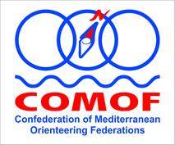 | CONFEDERATION OF MEDITERRANEAN ORIENTEERING FEDERATIONS  www.comofed.org  Via Della Malpensada 74, 38123 Trento, Italy

APPLICATION FORM FOR COMOF COUNCIL RE-ELECTIONS

To be used for application for free place in COMOF Council since Mr Tamer death, until end of mandate period 2022, which will be elected during General Assembly meeting in Brive, France, 11th April 2020.

Federation/Country:

Responsible person:

Candidate name:

Candidate contacts data:

Candidacy for a position in COMOF:

Short CV:

NOTES:

-Deadline for applications is 31thMarch 2020, mailed to comof.secretary@gmail.com
-Applications must be supported and send by National Federation member of COMOF, not by individual candidates.
-Since official COMOF language is English, please consider the need that all candidates for any position in COMOF must be fluent in English language.
-We would also like to encourage all National federations that candidates for the COMOF Council position to be present in person at the General Assembly in France, Brive, 11th April 2020

